**Practical No 2**

**Aim :** Install and configure Windows 9x,Windows NT, Windows 2000 & Windows XP Operating Systems.

**Apparatus:** Computer System and CD with the operating system files. [Windows XP]

**Theory :**

**Installation :**

1. Insert the Windows XP CD into the system through the CD/DVD drive.
2. When the windows startup menu is displayed, press ENTER to set up windows XP.
3. Press page down to scroll the agreement till the end.
4. Agree to user license, press F8 to agree to the terms.
5. Select the hard disk to proceed with the installation process.
6. Choose how to format the hard disk to perform clean install.
7. Click proceed and start the installation.
8. After the installation is completed, the computer system will restart, after the computer restarts agree to the terms and conditions pop up.
9. Let the installation complete.
10. Once the installation completes, the windows XP logo will appear and the system will boot up and Welcome screen will appear.
11. Click next and select the default softwares and drivers you want to install in your system in the pop up.
12. After the computer installation of required drivers is complete, the desktop will load with recycle bin icon, now your computer system with Windows XP is ready to operate.

**Output :–**

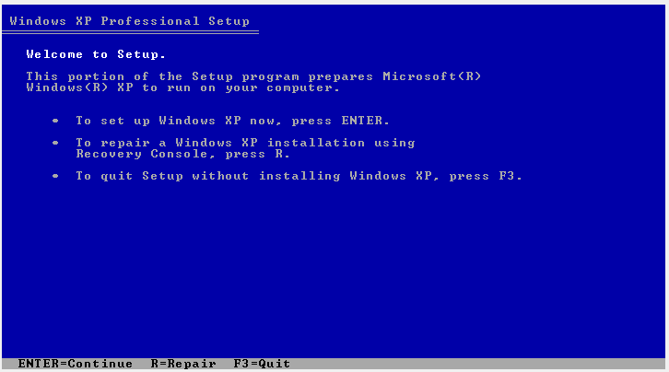

2.1. Installation menu

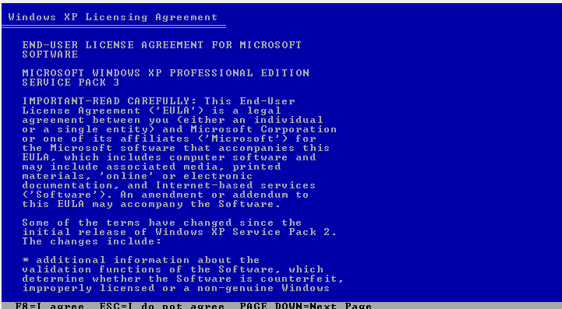

2.2. User Agreement

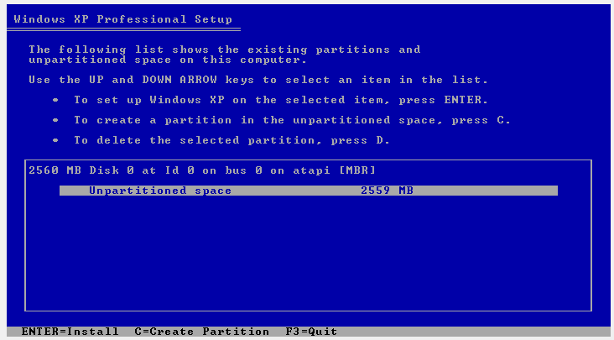

2.3. Select partition/disk to install OS

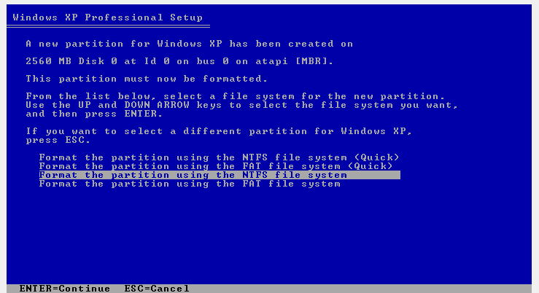

2.4. Format disk

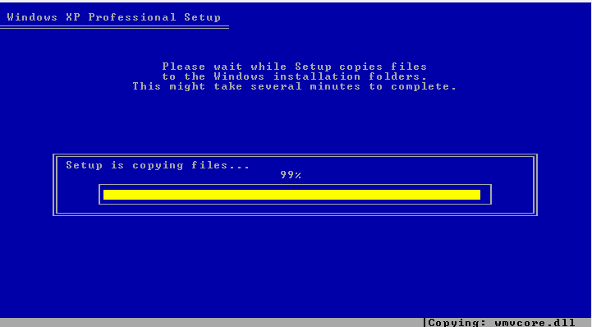

2.5. Formatting Disk

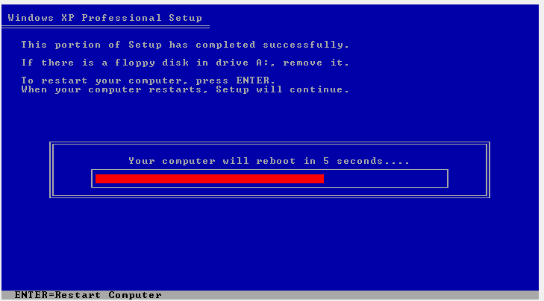

2.6. Computer System getting ready to restart after formatting hard disk and copying contents into it

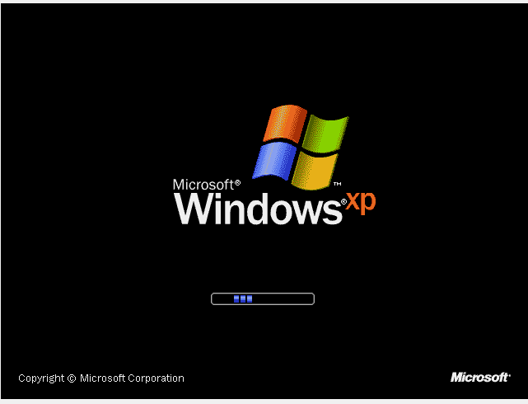

2.7. First boot up of the computer

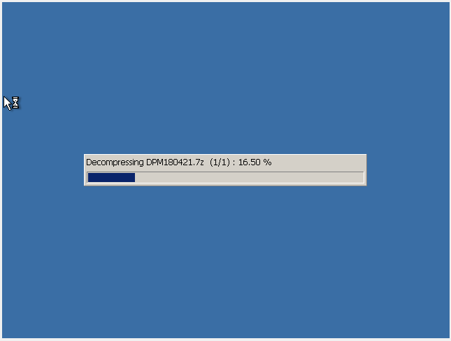

2.8. Decompression of the Operating System files

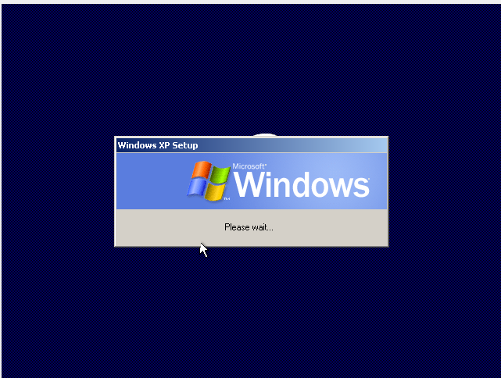

2.9. Windows XP Setup pop up window

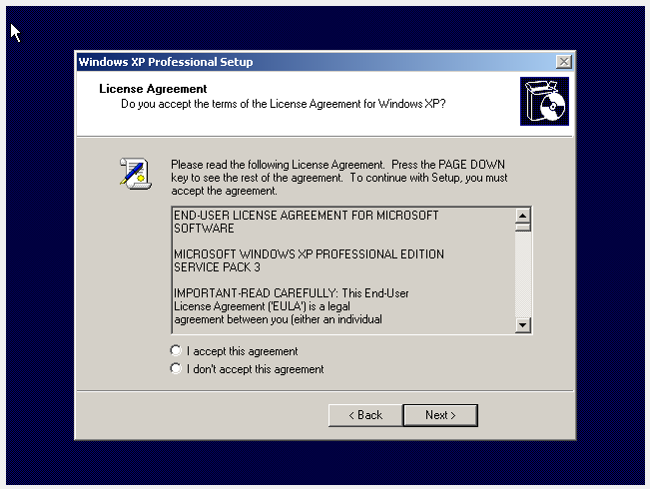

2.10. Windows XP License Agreement

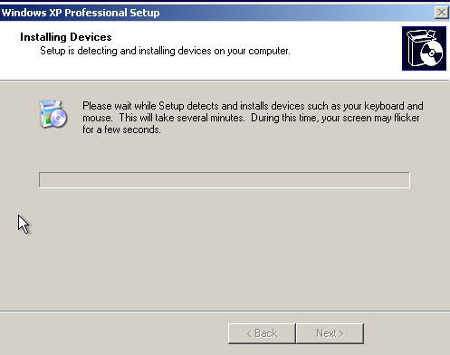

2.11. Installing various essential devices to the computer system.

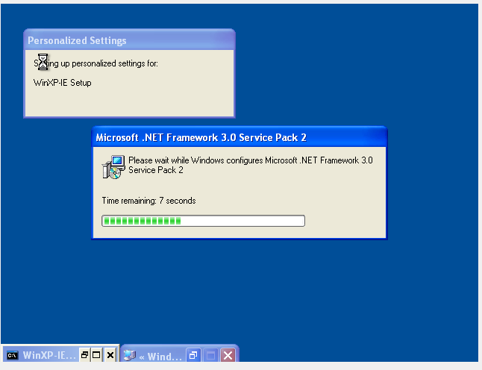

2.12. Installing the default suggested software in the System.

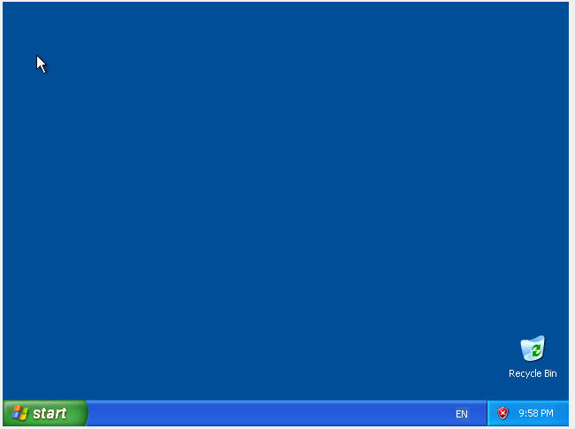

2.13. View of Desktop of windows system

**Conclusion**:

Hence, by performing this practical I got to learnt about various operating system, the installation process of these operating systems, and I also learnt about virtualization as I executed the software using the process of virtualization. I also installed windows XP on my computer system and configured it.